Elastic Load Balancing (ELB) is a service in Amazon Web Services (AWS) that operates dynamically to distribute incoming traffic across a set of targets, which can include EC2 instances, containers, and IP addresses. This distribution occurs seamlessly across one or more Availability Zones, enhancing both availability and fault tolerance.

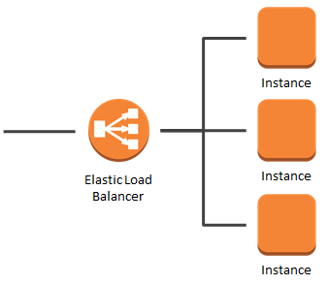

**Key features of Elastic Load Balancing include:**

1. Automatic Distribution:

ELB automatically and efficiently spreads incoming traffic across multiple targets, helping to optimize resource utilization and ensure a balanced distribution of workloads.

2. Health Monitoring:

The service continuously monitors the health of registered targets. It assesses the status of each target and directs traffic only to those targets that are deemed healthy. This health-based routing contributes to improved reliability and performance.

3. Availability Zone Support:

ELB can distribute traffic across multiple Availability Zones, providing redundancy and high availability. This ensures that if one Availability Zone encounters issues, traffic can be directed to healthy targets in other zones.

4. Load Balancer Types:

AWS offers different types of load balancers, allowing you to choose the one that best fits your specific requirements. These include the Application Load Balancer (ALB), Network Load Balancer (NLB), and Classic Load Balancer.

1. **Application Load Balancer (ALB**): Ideal for routing HTTP/HTTPS traffic and provides advanced features like content-based routing.
2. **Network Load Balancer (NLB):** Designed for handling TCP, UDP, and TLS traffic, making it suitable for applications with high performance and low-latency requirements.
3. **Classic Load Balancer:** The original load balancer type, supporting both HTTP/HTTPS and TCP traffic.
4. **Gateway Load Balancer (GWLB):** The Gateway Load Balancer is designed for distributing network traffic to a fleet of third-party virtual appliances. It is particularly useful for scenarios where advanced networking, security, or other services need to be applied to the traffic flow.

**The OSI layers supported by various AWS load balancers:**

1. Network Load Balancer (NLB):

- OSI Layer: Layer 4 (Transport Layer)

- Protocol: Handles TCP and UDP traffic.

2. Classic Load Balancer:

- OSI Layer: Layer 4 (Transport Layer)

- Protocol: Distributes traffic based on TCP/UDP port information.

3. Application Load Balancer (ALB):

- OSI Layer: Layer 7 (Application Layer)

- Protocol: Primarily designed for HTTP and HTTPS traffic, supports advanced routing based on content.

4. Gateway Load Balancer (GWLB):

- OSI Layers: Both Layer 4 (Transport Layer) and Layer 7 (Application Layer)

- Protocols: Supports both Layer 4 (TCP/UDP) and Layer 7 (HTTP/HTTPS) functionalities. Ideal for handling network traffic and integrating with third-party virtual appliances.